20th FCJC National Prayer Gathering
“In the world you will have trouble, but have courage, I have conquered the world!” - Jn.16:33
October 1-3, 2021

ORDER FORM
Last Name: |  |  | First Name:
Address: |  | City: |  |  | State: | Zip:
Email: | Phone No: |  |  | FCJC Area:

Unisex T-Shirt Sizing Chart (Fill the Quantity)
Color | Small | Medium | Large | X-Large | XX-Large | XXX-Large | Total No.  T-Shirt
 | $12.00 |  |  |  | $18.00
Black
Green
Yellow
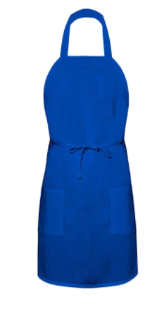
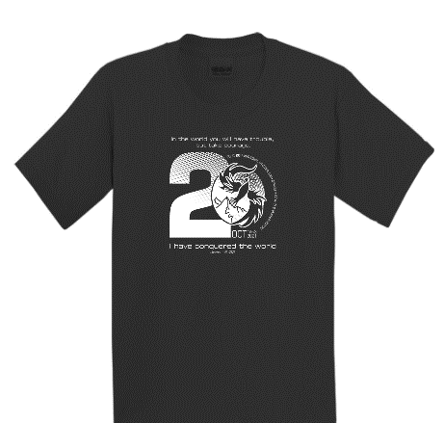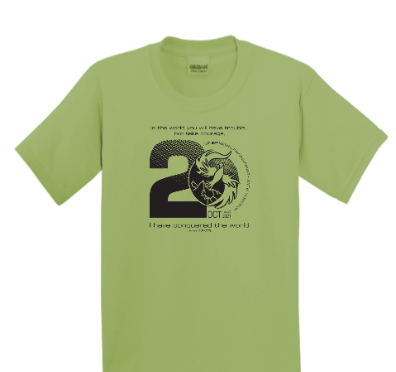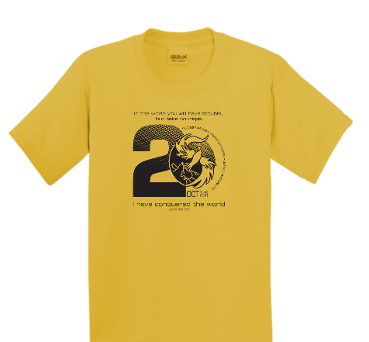
CTRL + MOUSE CLICK TO ENLARGE THE IMAGE

Order Summary
Item | Cost per Item | Order Quantity | Total Amount Due | Comments
T-Shirts (S-XL) | $12.00
T-Shirts (2XL-3XL) | $18.00
FCJC Apron (Blue) | $10.00
FCJC Iron on Patch | 3 for $5.00

NorCal ONLY Instructions:
- To ensure T-shirts are delivered before Oct 1, the deadline is September 8, 2021.
- Fill out the required information. Email, Phone Number, and Address are mandatory information.
- Save the registration to your computer.
- Email the “NPG Order Form” you filled out to NorCal Area NPG Coordinator (RhettTejada@gmail.com).
- When emailing, put in the subject line of the email “NPG Order Form”.
- When making a T-Shirt payment, the preferred method is via Zelle. Please ensure to put a remark that it's for "NPG T-Shirt Order Payment". The NorCal FCJC Zelle is "fcjcnorcalcouncil@gmail.com" or please write a check payable to "FCJC" and submit the check to your Household servant leader or mail to the NorCal NPG Coordinator.

NorCal NPG Coordinator:
Rhett Tejada Email Address: RhettTejada@gmail.com
Phone #: 916-308-8764
Address: 9787 Partington Circle, Elk Grove, CA 95757

